Assignment 4.3

1. States = rownames(US Arrests)

Get states names with ‘w’.

Solution:

grep(pattern = “w”, x = s, value = TRUE)

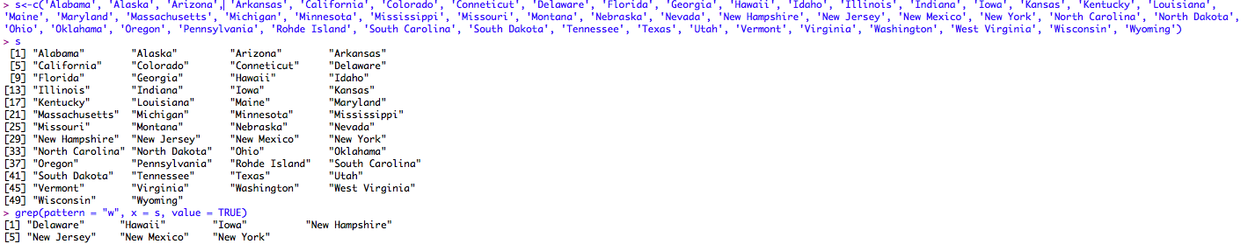

Get states names with ‘W’.

Solution:

grep(pattern = “W”, x = s, value = TRUE)

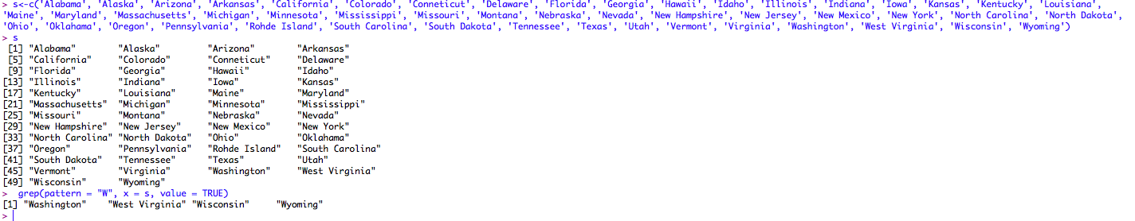

2. Prepare a Histogram of the number of characters in each US state.

Solution:

